**FTT Phoenix – 2016**

Looking Forward – Draft 1

What did we learn from our experience with FTT? What do we need to keep in mind as we move forward?

1. Family privacy boundary: We spent a lot of time developing this in the original FTT. We can revisit this in the future (<http://screencast.com/t/ku2lppSA9a3L>). Is there an more effective method? Privacy is very important.
2. Father/Mother side toggle: This is a key feature that we need to keep: <http://screencast.com/t/Bc5xIMqy7Ldy>
3. Lock profile when in edit mode: When a user is editing a profile, that profile is locked so that other users can not edit at the same time. If user A is updating profile for family member C and user B tries to edit same profile, he will be see message like “this profile is currently being updated by another person”.
4. Real time updates: When a change is made by *User A*, that change is automatically seen by User B. He does not need to refresh screen or log on again to see changes.
5. Mobile friendly: Must use a responsive theme/format that can adapt to tablets and smartphones.
6. Site must use effective language packs
7. Site should operate under different domain names – MyNativeRoots.com, FamilyTreeTop.com, etc.
8. Relation map: We need a relation map that is small and fast that we can use in the profile section (<http://screencast.com/t/SbSf09Eu5No>). This is a key feature.
9. We need an effective method of inviting other user to join the tree (by email and, if possible, by Facebook invite)
10. We need to be able to pull data from Facebook to FTT (timeline feeds, photos, dates, etc.)
11. Can we program in a way that will make it easier to convert to iPad app in the future?
12. More?

**Screenshots of Original FTT:**

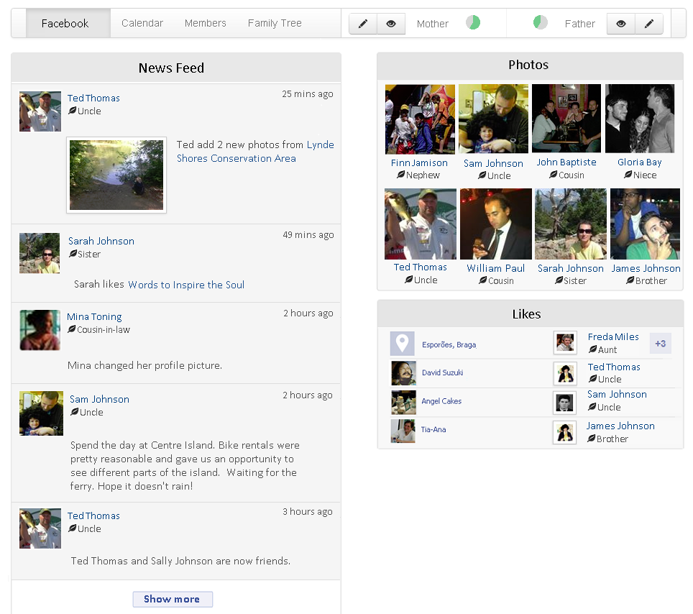

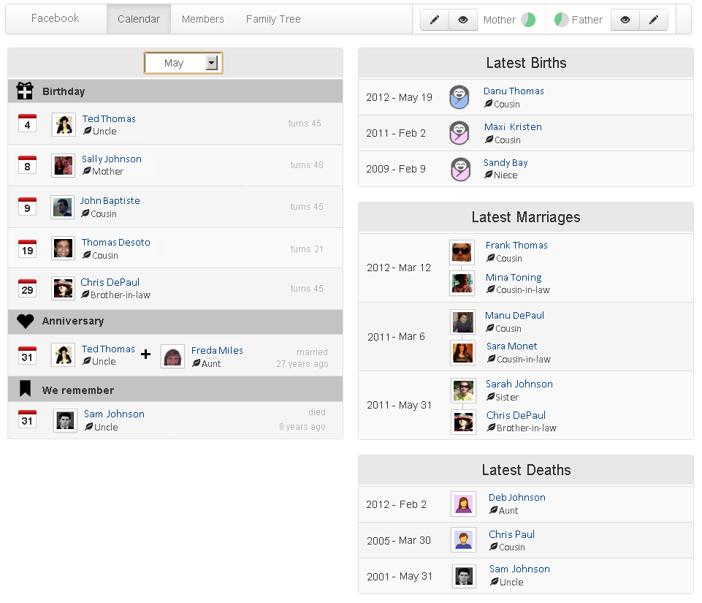

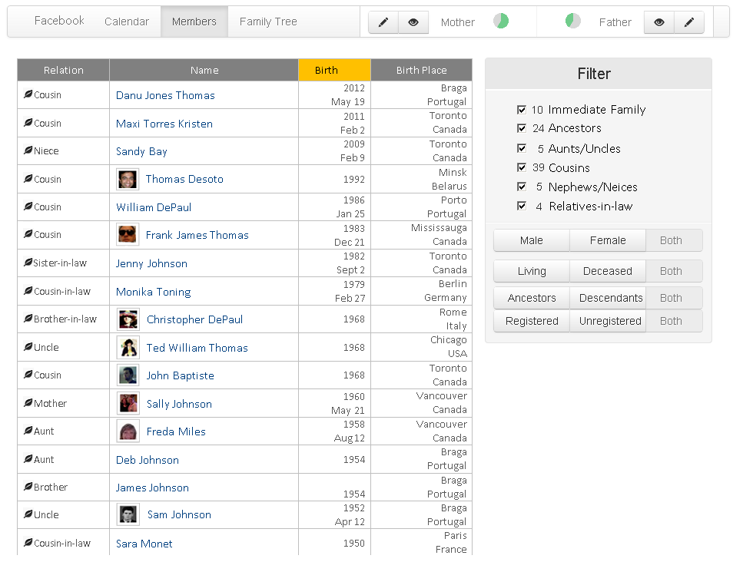

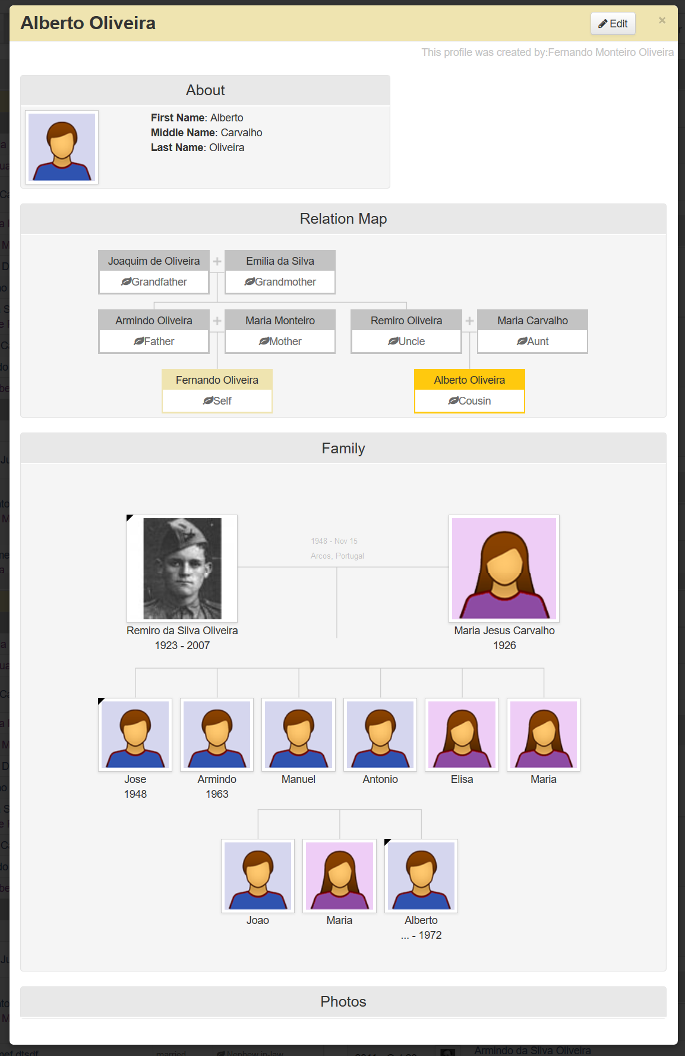

**Brainstorming:**

Mobile:

